Open Cloudera Manager via web interface on URL http://<public_ip>:7180

Login: admin

Password: admin

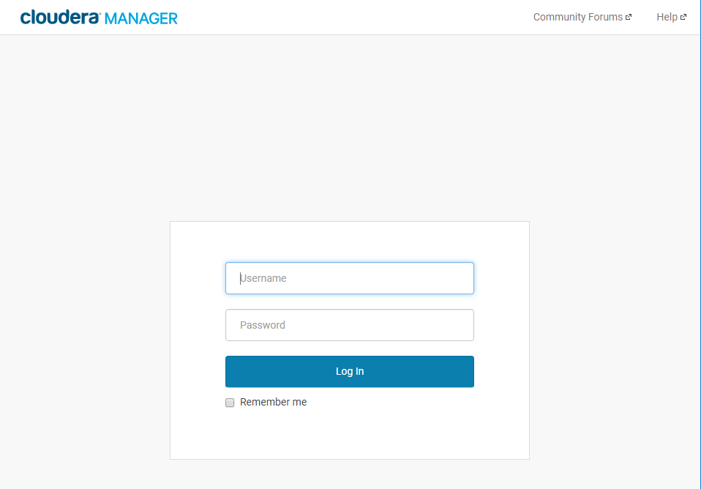

Accept user agreements

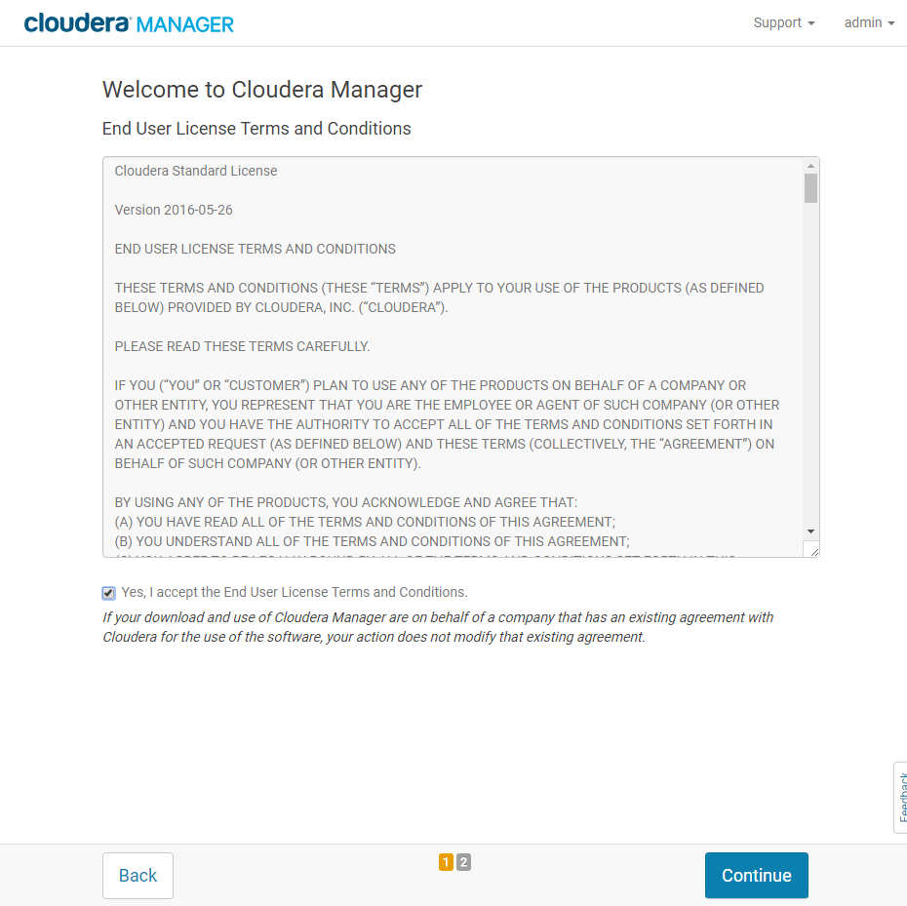

Choose 60 days trial plan.

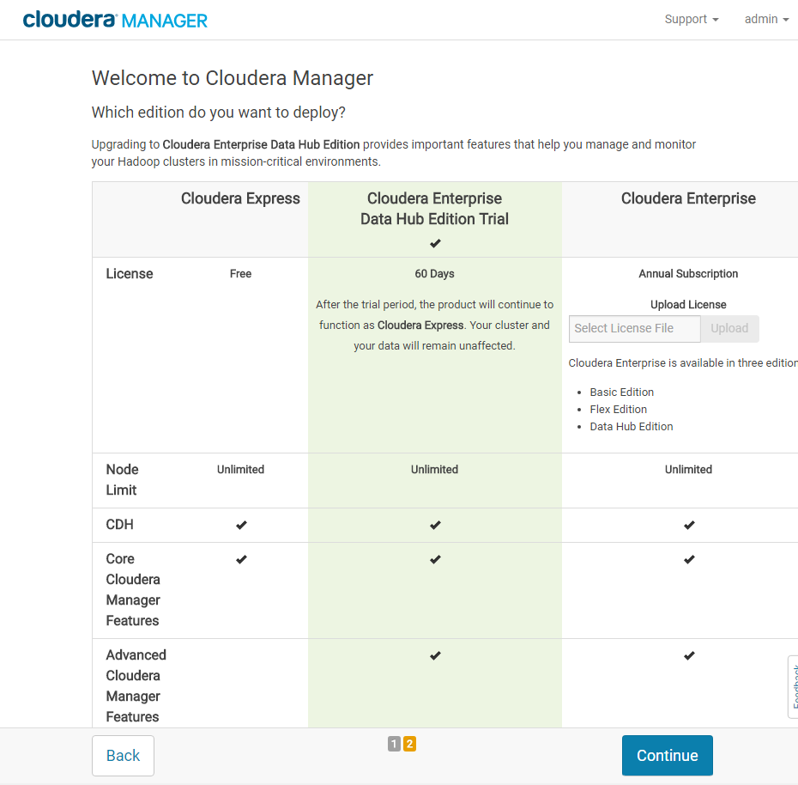

Press Continue once more.

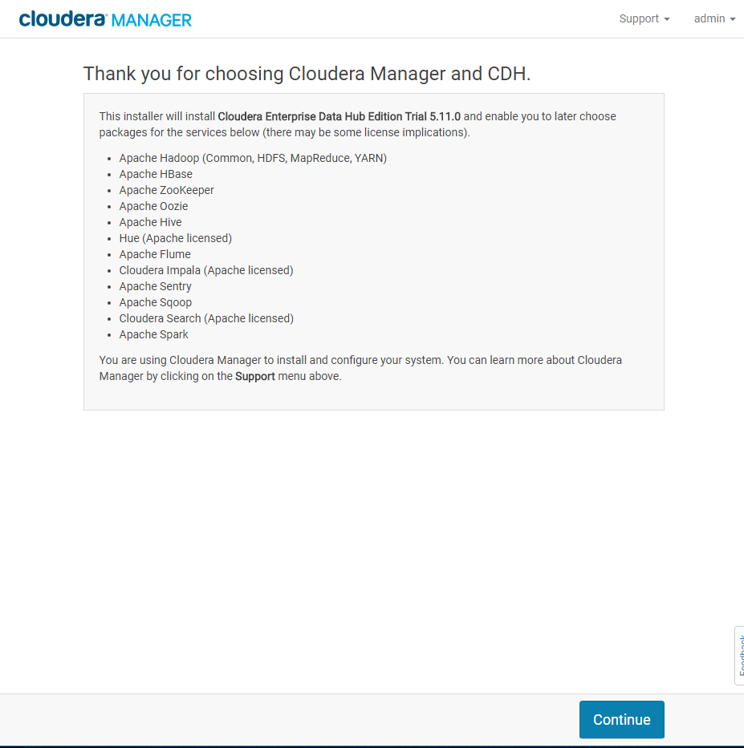

Place all three nodes private DNS to textarea. Press Search.

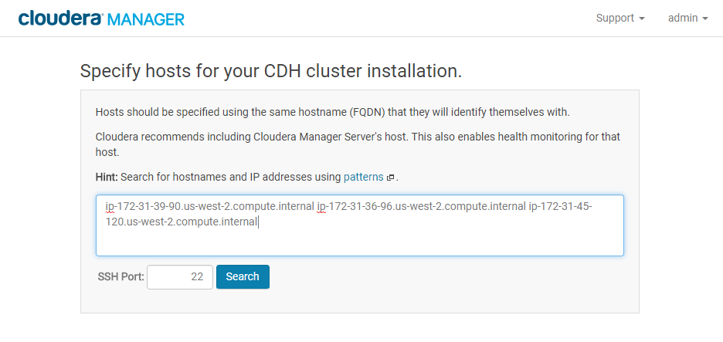

Press Continue

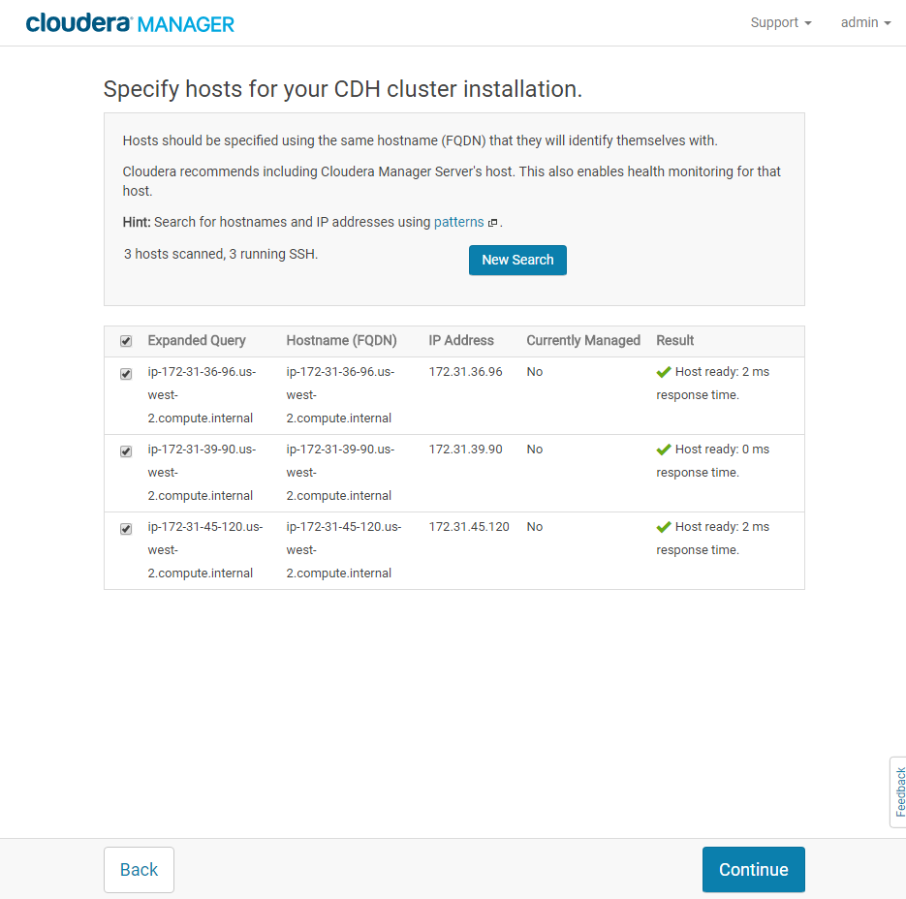

Change nothing, press Continue.

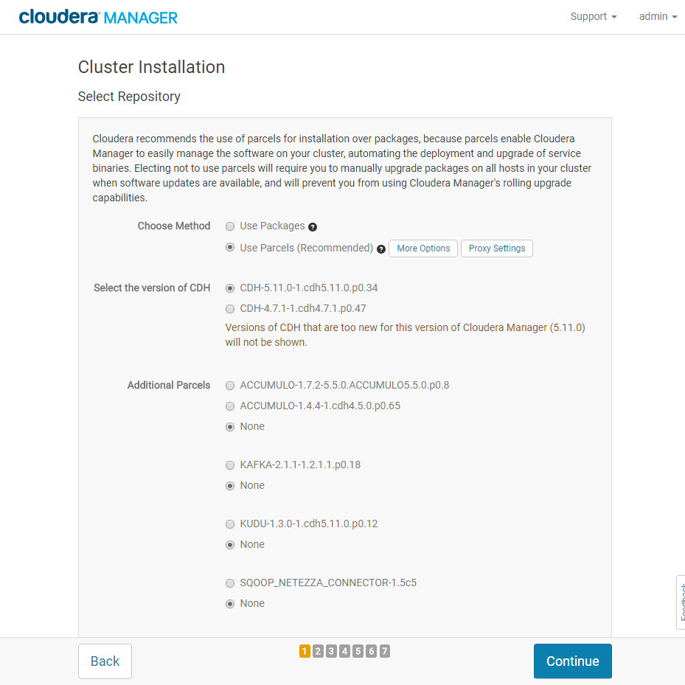

Set checkbox “Install Oracle Java SE Development Kit (JDK)”. Continue.

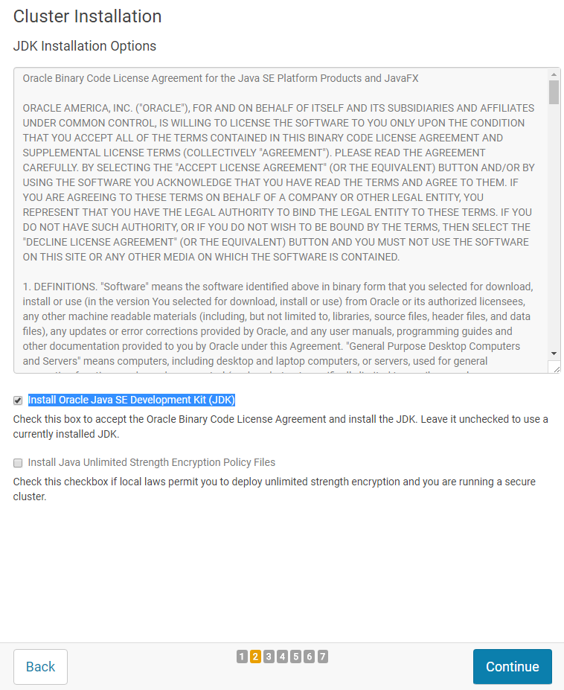

**NOT use Single user mode!** Leave checkbox empty. Press Continue.

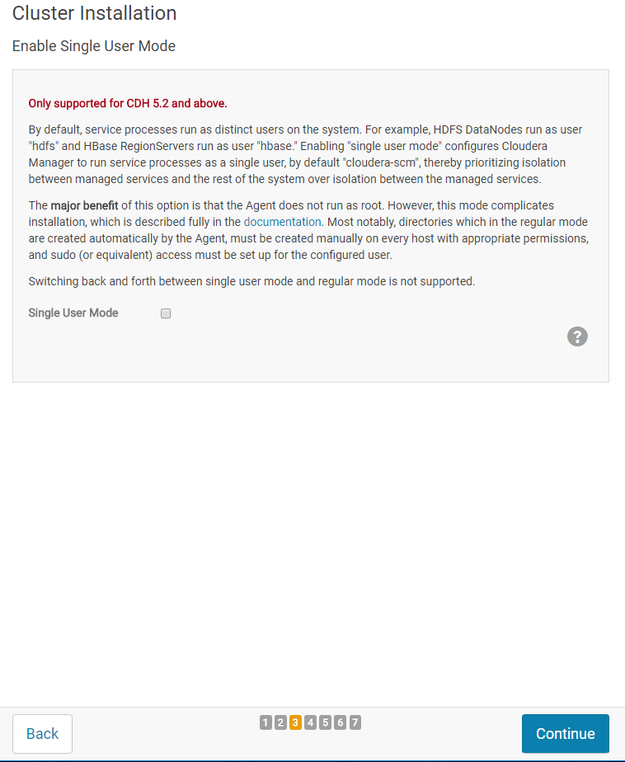

Add your user name and your SSH PPK key file (password, if you use password when generate PPK file). Press Continue.

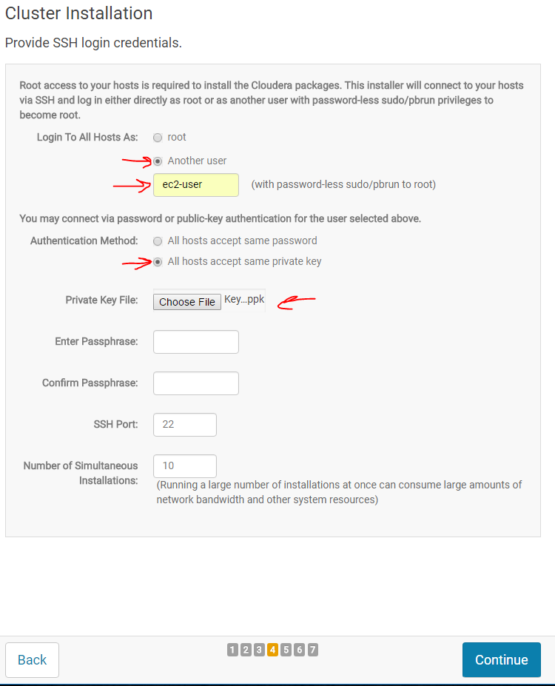

See installation progress …

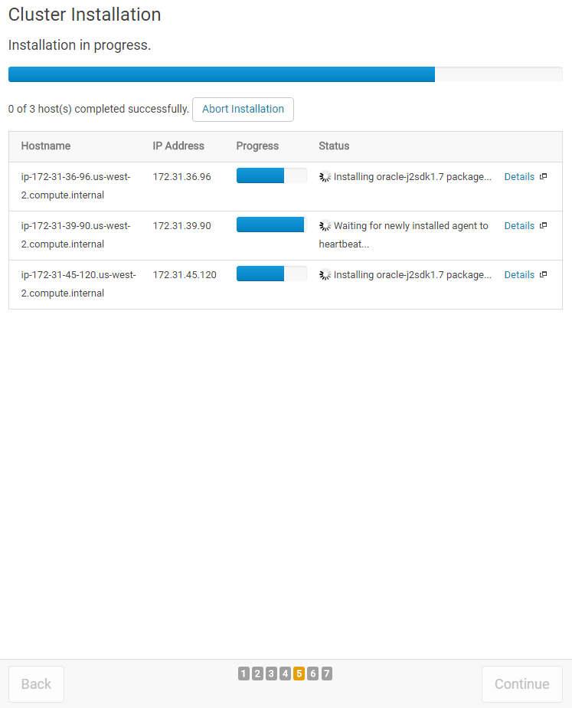

When Continue button became Blue – press it.

Enjoy cluster installation progress…

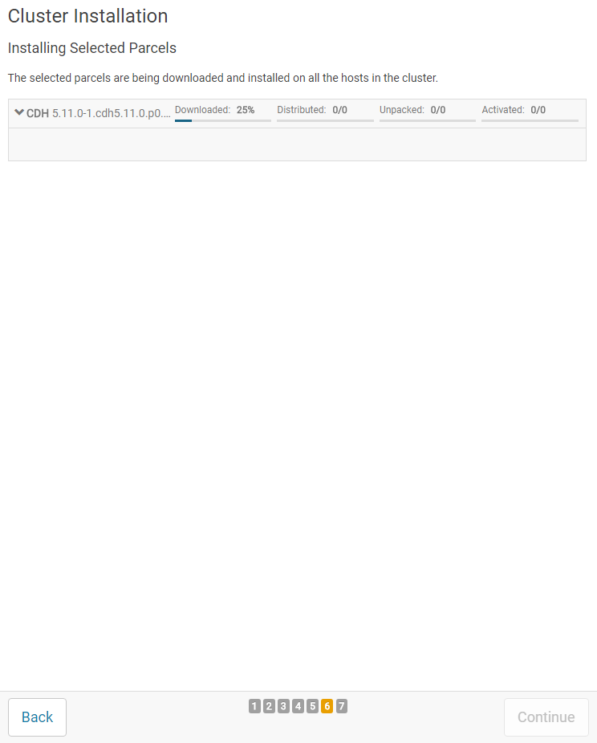

When Continue button became Blue – press it.

If you see errors here it might case by:

* Small node partition size. Less than 32 GiB.

Don`t mind if not all inspections green, unless Finish button is active. Just press Finish.

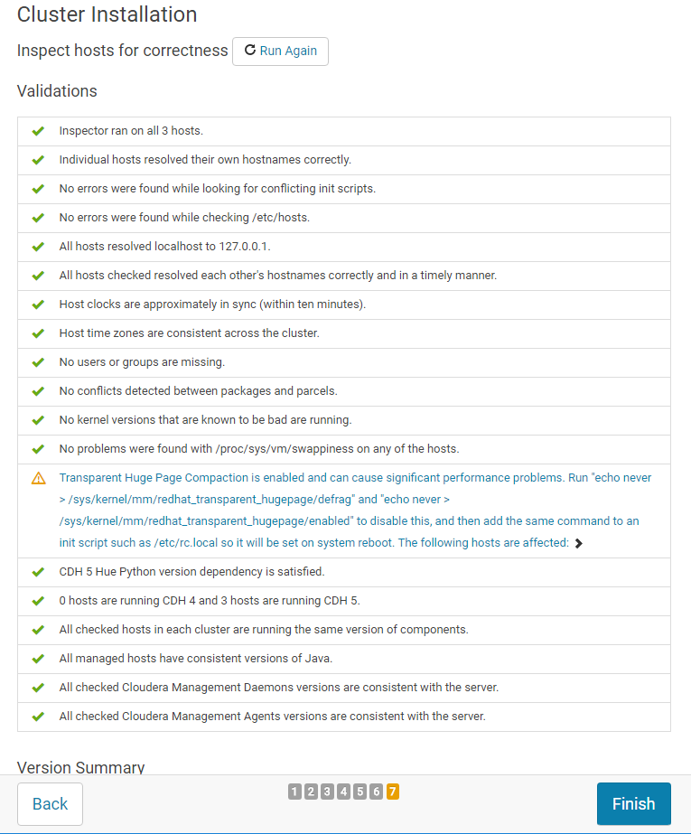

Choose Custom services.

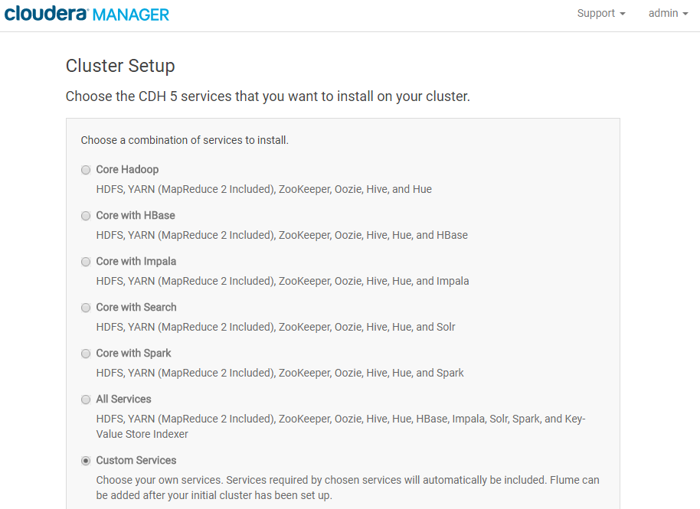

There are details:

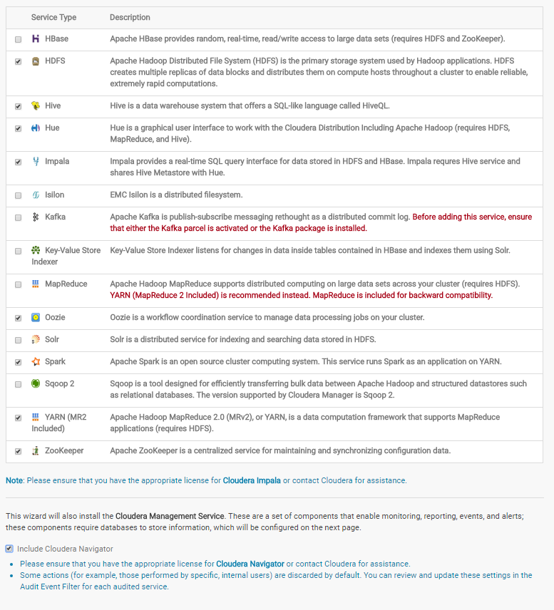

Press Continue.

Leave Default node distribution. Press Continue.

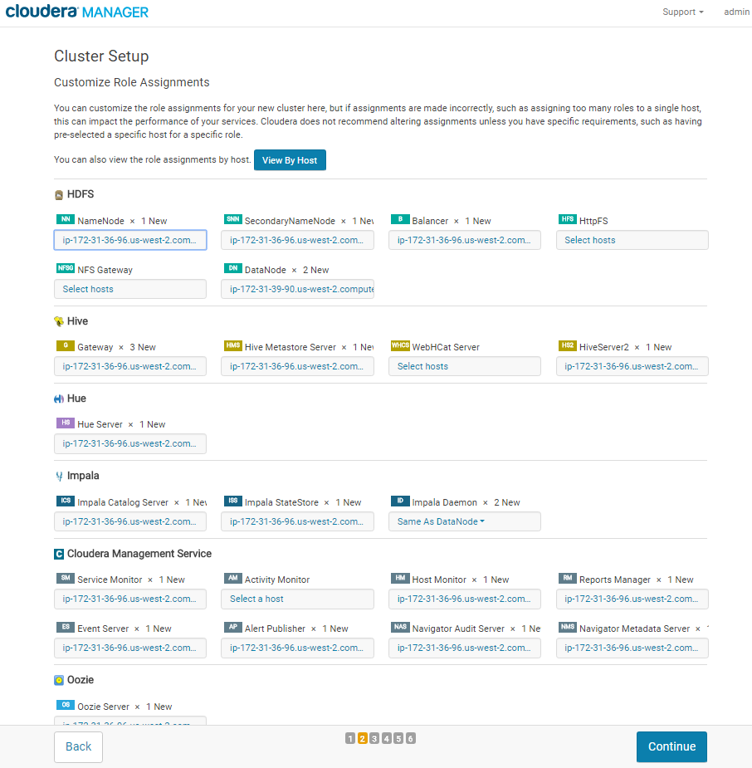

Radio select should be on “Use embedded data base”, press Test Connection. After success test – press Continue.

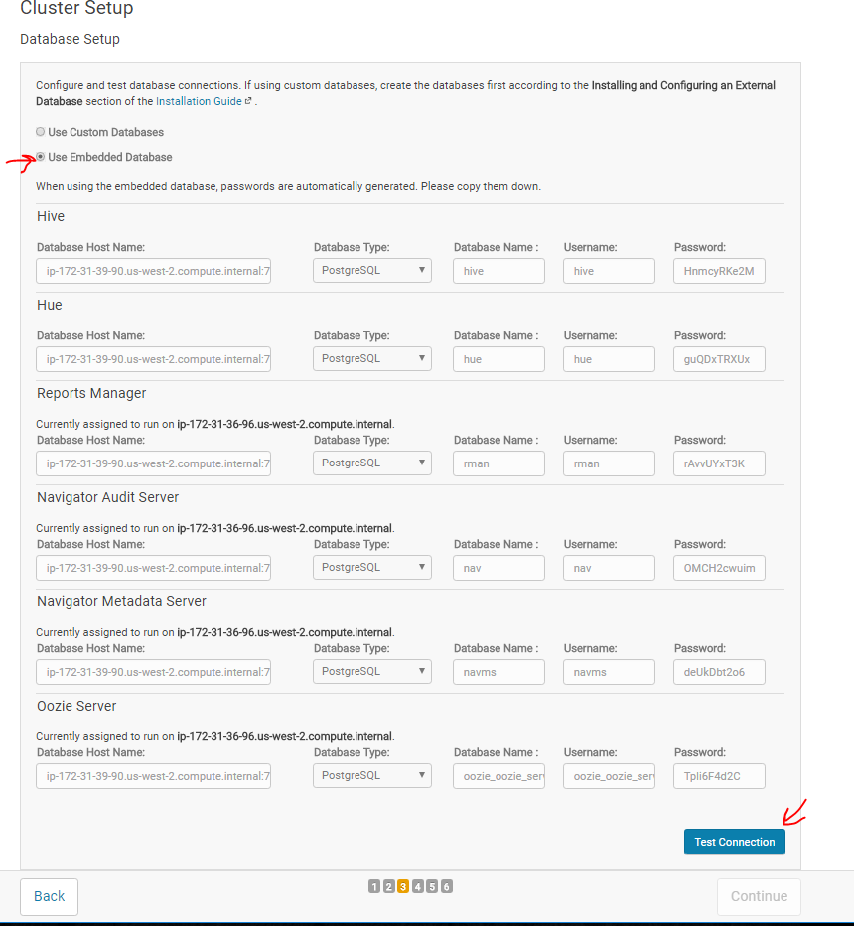

Watch review …



Just Continue.

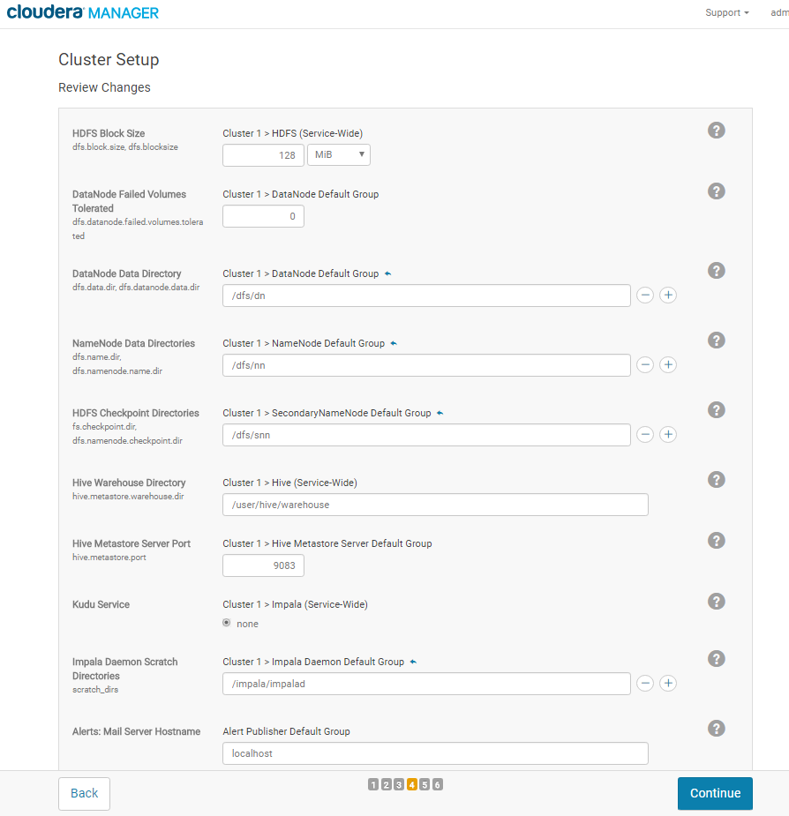

Set-up will took several minutes or even dozen of minutes. You can make coffee-break. It almost finishes.

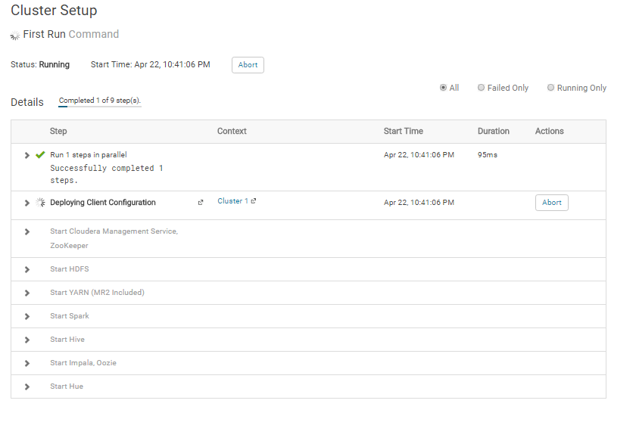

When Continue button became Blue – press it.

Press Finish



You should see nice dashboard  
